Reality is a much-debated topic, and has been for many years through out history. Countless numbers of philosophers as well as scientists have tackled the question of what makes up our surroundings and what accounts for the entire phenomenon that we perceive. From multiple dimensions of existence, to theories of quantum mechanics and relativity, there have been many attempts to define this reality with precision and truth. What it seems to be is a conceptual organization of thoughts and definitions based on observations made by each individual. This leads us not only to an objective reality that follows certain rules according to an observer, but also to a subjective reality that can bend and change according to the will of the observer. These two sides have been chosen independently of each other for centuries and argued against each other. Unfortunately, when you use reality to argue against itself, you can no longer reach factual or plausible conclusions, as you cannot use half of something to define the whole. You can, however, use the two opposite sides of reality to define each other, and therefore the whole. In this sense, using objective definitions and subjective decisions, you can conceivably reach an accurate model of reality. All you need to begin is a probable structure.
Here, I will be getting into a field of science known as quantum mechanics, or sub-atomic particle physics. While this is known as an extremely complicated field, employing advanced mathematics, I assure you that you will not need any of that here. You see, I will be working with the philosophies behind each of the theories here, and so the math will be really inconsequential. I am interested in the “why” of quantum mechanics, not the “how.” Through the exploration and application of these concepts and philosophies. I intend on outlining an existence where all possibilities are occurring, and where the version of existence you are perceiving is based solely upon the conscious choices of each observer involved.
There is a philosophical idea that attempts to describe existence and the number of possibilities that exist. It has implications in the concept of destiny and fate, and can be used to support the concept that everything is possible. Any idea that can be conceived by a consciousness has a probability of not only existing, but occurring. It comes down to the decisions that each consciousness makes, as it is the decisions that create the interference in the infinite interactions of energy waves which ultimately make up the reality we perceive. It is known as the Multiverse, and has many startling yet supporting theories in the field of quantum mechanics. It all started one day, when someone noticed the dual nature of the particle.

Wave-Particle Duality
“Light simultaneously exhibits both the properties of a wave of energy and a particle of matter.”

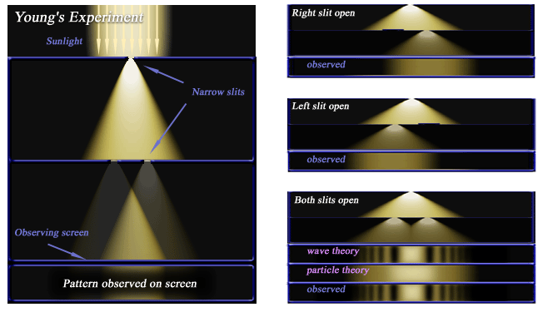
Double Slit Experiment: “Shoot electrons (or anything for that matter) at a screen with two slits and record their position of impact at a detector behind the screen. You will observe an interference pattern just like the one produced by diffraction of a light or water wave at two slits. This pattern will even appear if you slow down the electron source so that only one electron per second comes through. Classically speaking, every electron either travels through the first or the second slit. This means that we should be able to produce the same interference pattern if we ran the experiment twice as long, closing slit number one for the first half, then closing slit number two for the second half. This does not apply, as the pattern will not emerge. Furthermore, if we build little detectors around the slits in order to determine which path a particular electron takes, then this very measurement will destroy the interference pattern as well. This pattern is a result of the electron’s wave function being diffracted by both slits and interfering with itself. Until an observation is made, the position of a particle is described in terms of probability waves, but after the particle is observed, it is described as a fixed value. How to conceptualize the process of measurement is one of the great unresolved questions of quantum mechanics.”

Matter is Energy and Energy is Matter
“Today young people are beginning to realize that matter is nothing but energy reduced to a slow vibration.” -Bill Hicks

Heisenberg’s Uncertainty Principle
“The uncertainty principle states that you can not simultaneously know both the position and the momentum of a given object arbitrary to position.”

Probability Distributions
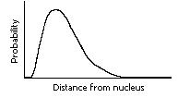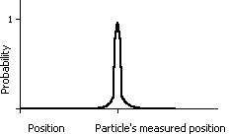
Explanation

Schrodingers Cat
Cat in a box w/isotope attached to gas canister in a sealed environment.

Copenhagen Interpretation of QM
“An atom state is indeterminate unless measured by an outside observer”
You must factor in the human consciousness as the observer into the equation.

Everett Many Worlds Interpretation of QM
“The many-worlds interpretation, formulated in 1956, holds that all the possibilities described by quantum theory simultaneously occur in a “multiverse” composed of mostly independent parallel universes. While the multiverse is deterministic, we perceive non-deterministic behavior as being governed by probabilities because we can observe only the universe we inhabit.”

Probability Distributions
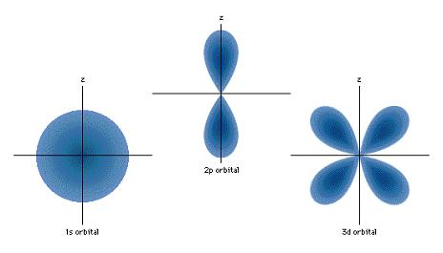
Applications

Quantum Entanglement
“In Schrodingers Cat, this is seen as the two separate parallel universes corresponding to a live cat, and a dead cat. Both of these states are formed, and they can have no interaction with each other. In other words, there currently does not exist a way to communicate across the separation of these states, or between one universe and another.”

Divergent States of Existence

Causeality
“Information can not travel faster than the Speed of Light”
“God does not play dice with the world.” – Albert Einstein

Entangled Pair: In this hypothetical experiment the scientists do not measure the spin of each particle right away. They send the two particles, called an entangled pair, off in opposite directions until they are far apart from each other. The scientists then measure the spin of one of the particles, fixing its value. Instantaneously, the spin of the other particle becomes known and fixed. It is no longer a fuzzy probability but must be the opposite of the other particle, so that their spins will add to zero. It is as though the first particle communicated with the second. This apparent instantaneous passing of information from one particle to the other would violate the rule that nothing, not even information, can travel faster than the speed of light. The two particles do not, however, communicate with each other. Physicists can instantaneously know the spin of the second particle because they set the total spin of the system to be zero at the beginning of the experiment. In 1997 Austrian researchers performed an experiment similar to the hypothetical experiment of the 1930s, confirming the effect of measurement on a quantum system.

Microsoft® Encarta® Encyclopedia 2003. © 1993-2002 Microsoft Corporation. All rights reserved.

The Mind – An Example of an Entangled State


Consciousness: Non-conjugate Variables
“Suppose you have a varying signal such as a sound wave, and you want to know the exact frequencies in your signal at an exact moment in time. This is impossible. In order to determine the frequencies accurately, you need to sample the signal for some time, and you therefore lose time precision. Time and frequencies are “conjugate variables.” Two variables are conjugate if the associated variable operators do not commute. Look at position (X) versus momentum (p). Position is a measurement of coordinates on a grid relative to a zero point. Momentum is mass (m) multiplied by velocity, which is distance (d) over time (t).
X = (x,y,z) p = m * (d/t)
An accurate position requires a fixed distance and time. An accurate momentum requires a varied distance and time. Therefore, neither may be measured together accurately because none of the variable operators can be shared between the two.

Deterministic Multiverse – Objective vs. Subjective
"As below, so above; and as above, so below. With this knowledge alone you may work miracles."
-The Emerald Tablet of Hermes (www.golden-dawn.com)
“Framework 1 and Framework 2 -Seth

Consciousness in the Multiverse

